**THE GAME CHANGER for closed-back Audiophile headphones**

**Sennheiser sets new audiophile standard with launch of HD 820**

***Wedemark/Las Vegas, 8 January 2018 –* Sennheiser is redefining the limits of audiophile sound – with the new HD 820** **which will first be showcased at CES. The closed-back dynamic stereo headphones deliver astonishingly transparent sound, thanks to a unique glass transducer cover that minimizes resonances – an innovation that ensures an incredibly realistic and natural sound field.**

With a more than 70-year history of setting performance standards in sound, Sennheiser is once again redrawing the map with the creation of the HD 820. The new circumaural dynamic stereo headphones shatter expectations of what was thought possible from a closed-back model and set a new benchmark in sound quality for this type of design.

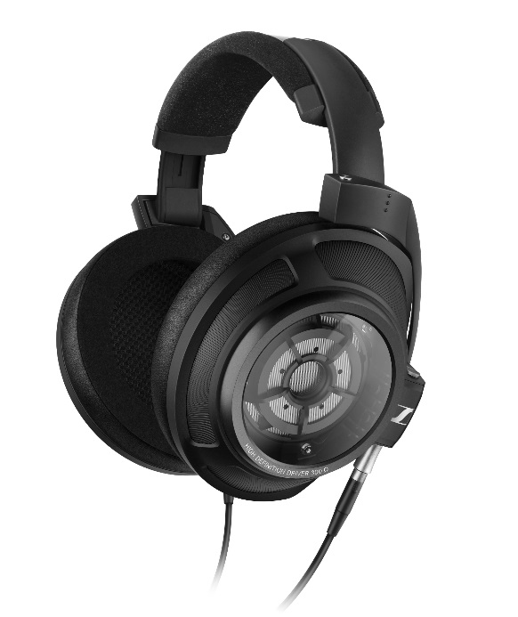

The closed-back HD 820 headphones deliver astonishingly transparent sound, thanks to a unique glass transducer cover that minimizes resonances.

“Whether on the move, at work or at home, the passionate audiophile will always want to appreciate their music to the full,” said Axel Grell, Portfolio Management Consumer at Sennheiser. “Usually, high-end headphones require an open-back design, which has placed limits on where you can enjoy true audiophile sound. The HD 820 is a game changer that delivers exceptional sound while insulating the listener from their environment. I consider them to be the most transparent-sounding closed-back headphones in the world.”

The HD 820 establishes a new reference standard for its class, with an incredibly realistic and natural sound field. This breakthrough performance has been achieved through a special innovation: Over each of the legendary Sennheiser Ring Radiator transducers are unique glass covers. Revealing the acoustics within, the patent-pending curved Gorilla glass serves to reflect the sound waves from the rear of the transducer to two absorber chambers, which results in minimal resonance.

**Engineering an unparalleled listening experience**

Manufactured in Germany, the headphones feature a robust metal headband with an inner damping element, and silver-cladded OFC cables and gold-plated plugs. Meanwhile, the ear pads have been handcrafted from high-quality non-allergic synthetic leather and microfiber to cushion and insulate the listener from ambient noise. Together, these carefully selected components and materials delight every sense while producing an unparalleled listening experience.

**Complete the Sennheiser audiophile experience**

Sennheiser’s HDV 820 amplifier for dynamic headphones is the perfect companion to the HD 820. With its consistently symmetrical signal processing and extremely low harmonic distortion, the amplifier ensures unadulterated and perfect music enjoyment when paired with audiophile headphones. A specially tuned symmetrical, impedance matching cable with low capacitance is included with the HD 820 to guarantee seamless performance from this audiophile duo.

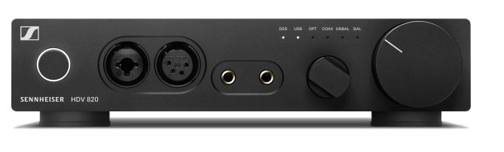

Sennheiser’s HDV 820 amplifier for dynamic headphones is the perfect companion to the HD 820.

Both HD 820 and HDV 820 feature Pentaconn connectors – the new standard for balanced outputs. This offers a lower contact resistance than all other connections for headphones to produce minimal distortion and a more transparent sound reproduction.

The new HD 820 will be available from early summer 2018 for 2,399 EUR/2,399.95 USD (MSRP).

CES 2018 takes place in Las Vegas from January 9 to 12. To experience and learn more about HD 820 and other product news, visit Sennheiser in South Hall 1, Booth 20606.

**About Sennheiser**

Sennheiser is shaping the future of audio – a vision built on more than 70 years of innovation culture, which is deeply rooted within the family-owned company. Founded in 1945, Sennheiser is one of the world’s leading manufacturers of headphones, microphones and wireless transmission systems. With 20 sales subsidiaries and long-established trading partners, the company is active in more than 50 countries and operates its own production facilities in Germany, Ireland and the USA. Sennheiser has around 2,800 employees around the world that share a passion for audio excellence. Since 2013, Sennheiser has been managed by Daniel Sennheiser and Dr. Andreas Sennheiser, the third generation of the family to run the company. In 2016, the Sennheiser Group had sales totalling €658.4 million. www.sennheiser.com

**Global Press Contact**

Sennheiser electronic GmbH & Co. KG

Jacqueline Gusmag

Public Relations Manager Consumer Electronics

Am Labor 1 • 30900 Wedemark

Phone: +49 (0)5130 600 – 1540

Email: [jacqueline.gusmag@sennheiser.com](mailto:jacqueline.gusmag@sennheiser.com)